ECE 465 Lab 6
Multiplexers
The purpose of this lab is to further enforce the idea of multiplexers and their applications.
- Recall that a multiplexer has input datalines of $2^{n}$ where the ratio of the output of a multiplexer is regarded as $2^{n}:nlog_{2}$. With $n$ input lines.
Look at the figure of the multiplexer below. Construct a truth table based on the behavior of the Multiplexer.
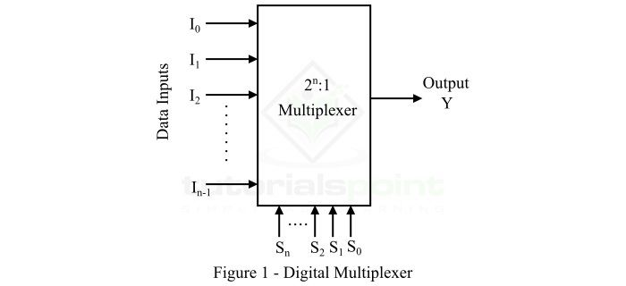

1b. Using circuitverse, create a 2:1 multiplexer using only basic gates and inverter.
ANSWER TO BE ADDED.
- Recall the previous lab where we introduced Verilog. The next part of this lab is to create a 2:1 multiplexer in Verilog and Modelsim.
ANSWER TO BE ADDED
- Recount the definition of a multiplexer. Is it possible to construct a 4:1 multiplexer by only using 2 multiplexers? If so, explain how and using Verilog, construct a 4:1 multiplexers.

